CS 255 System Design Document Template

UML Diagrams

UML Use Case Diagram
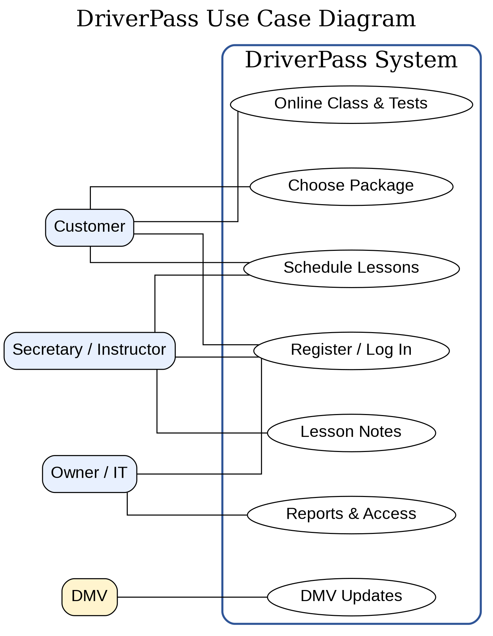

UML Activity Diagrams
The first activity diagram explains how a customer or secretary schedules a two-hour driving lesson. The process checks package hours and vehicle/driver availability before saving the appointment.
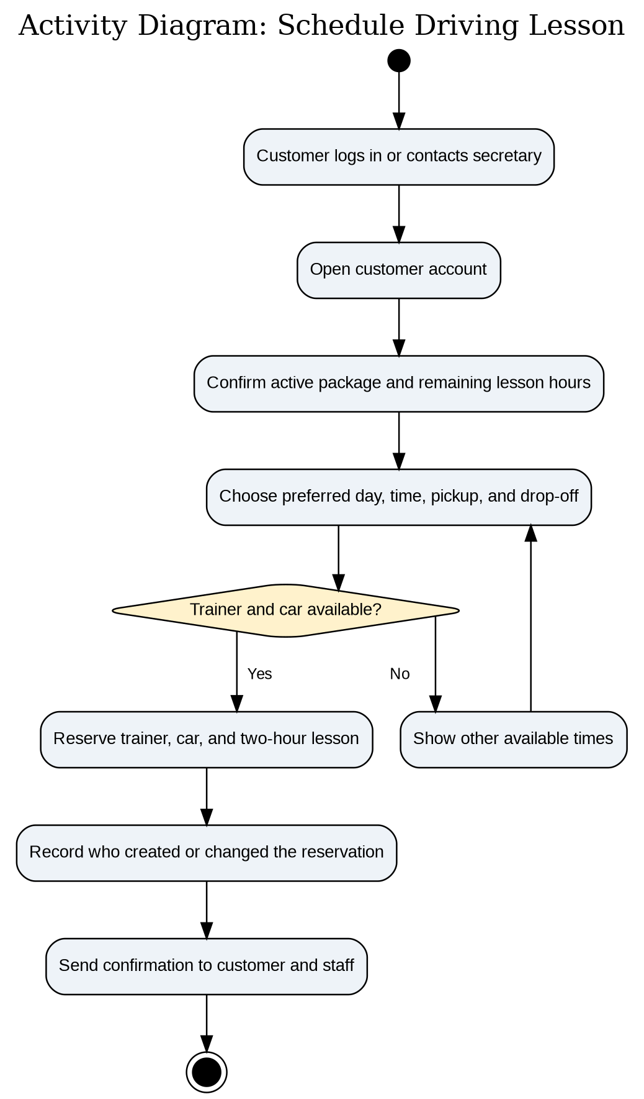

The second activity diagram explains customer registration and package selection. It allows online registration or secretary-assisted registration, checks package availability, processes payment, and activates the package.

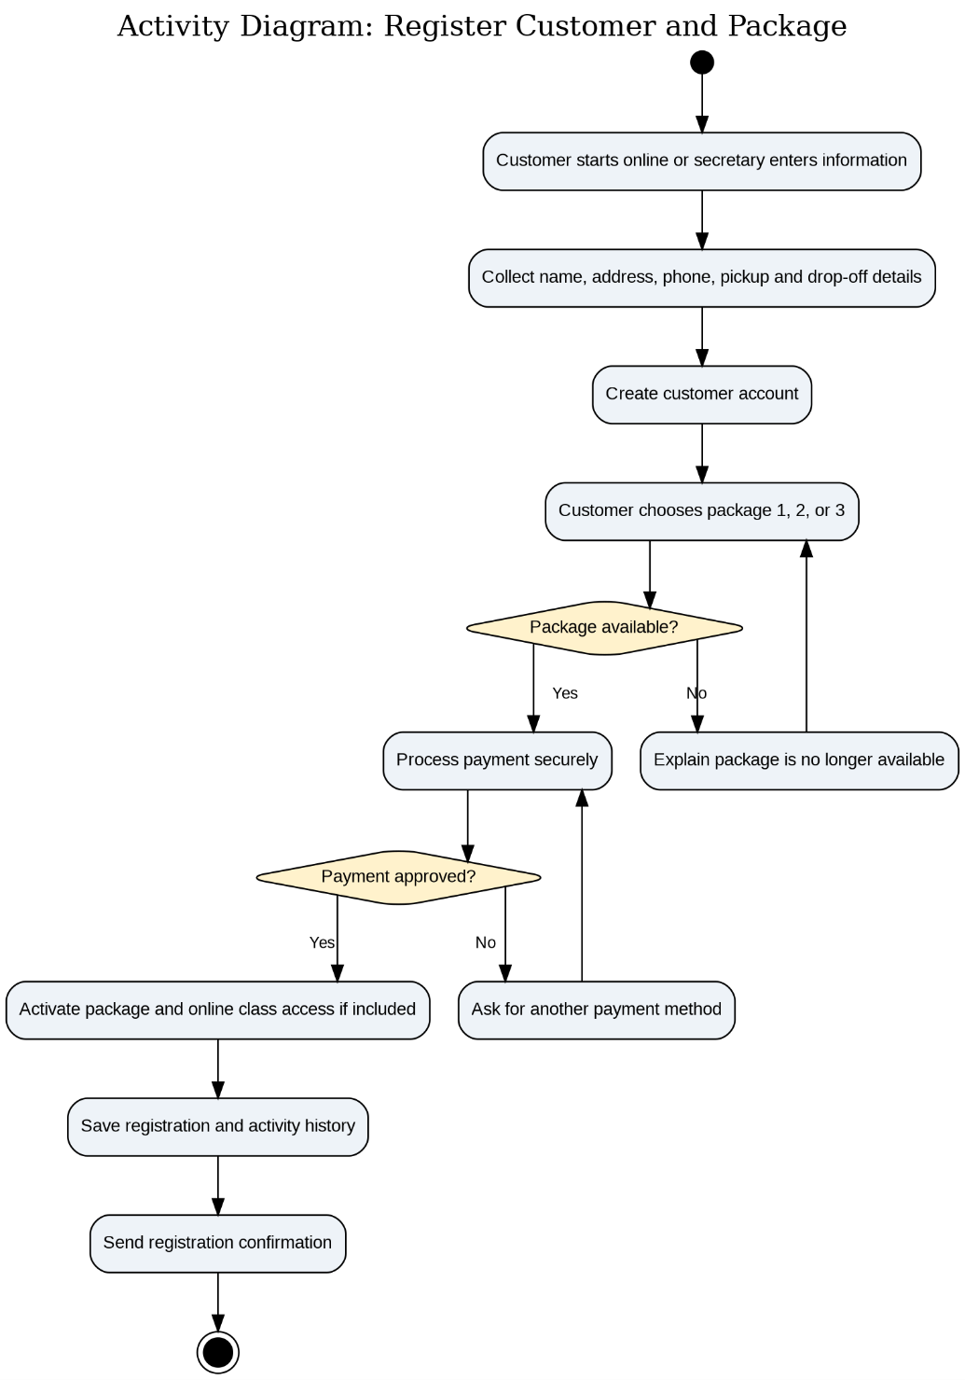

UML Sequence Diagram
The sequence diagram focuses on scheduling a driving lesson. It shows the order of communication between the customer or secretary, the website, the scheduling service, the database, and the notification service.
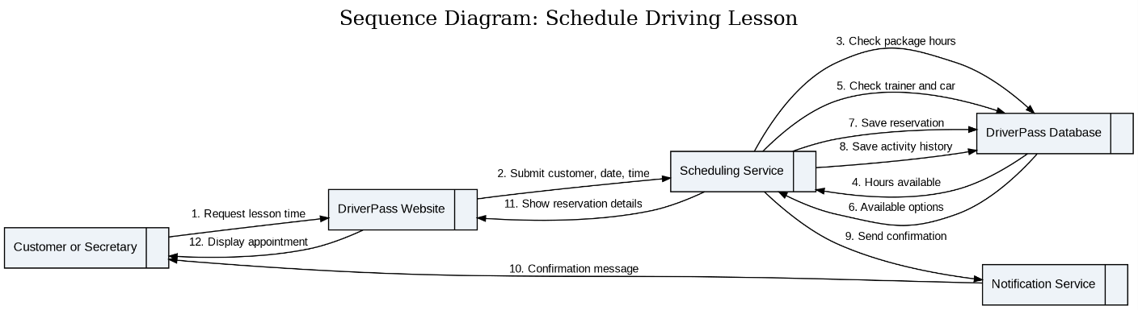

UML Class Diagram
The class diagram identifies the main information groups the system must store. These include users, customers, employees, training packages, reservations, vehicles, lesson notes, payments, practice tests, DMV updates, and activity logs.
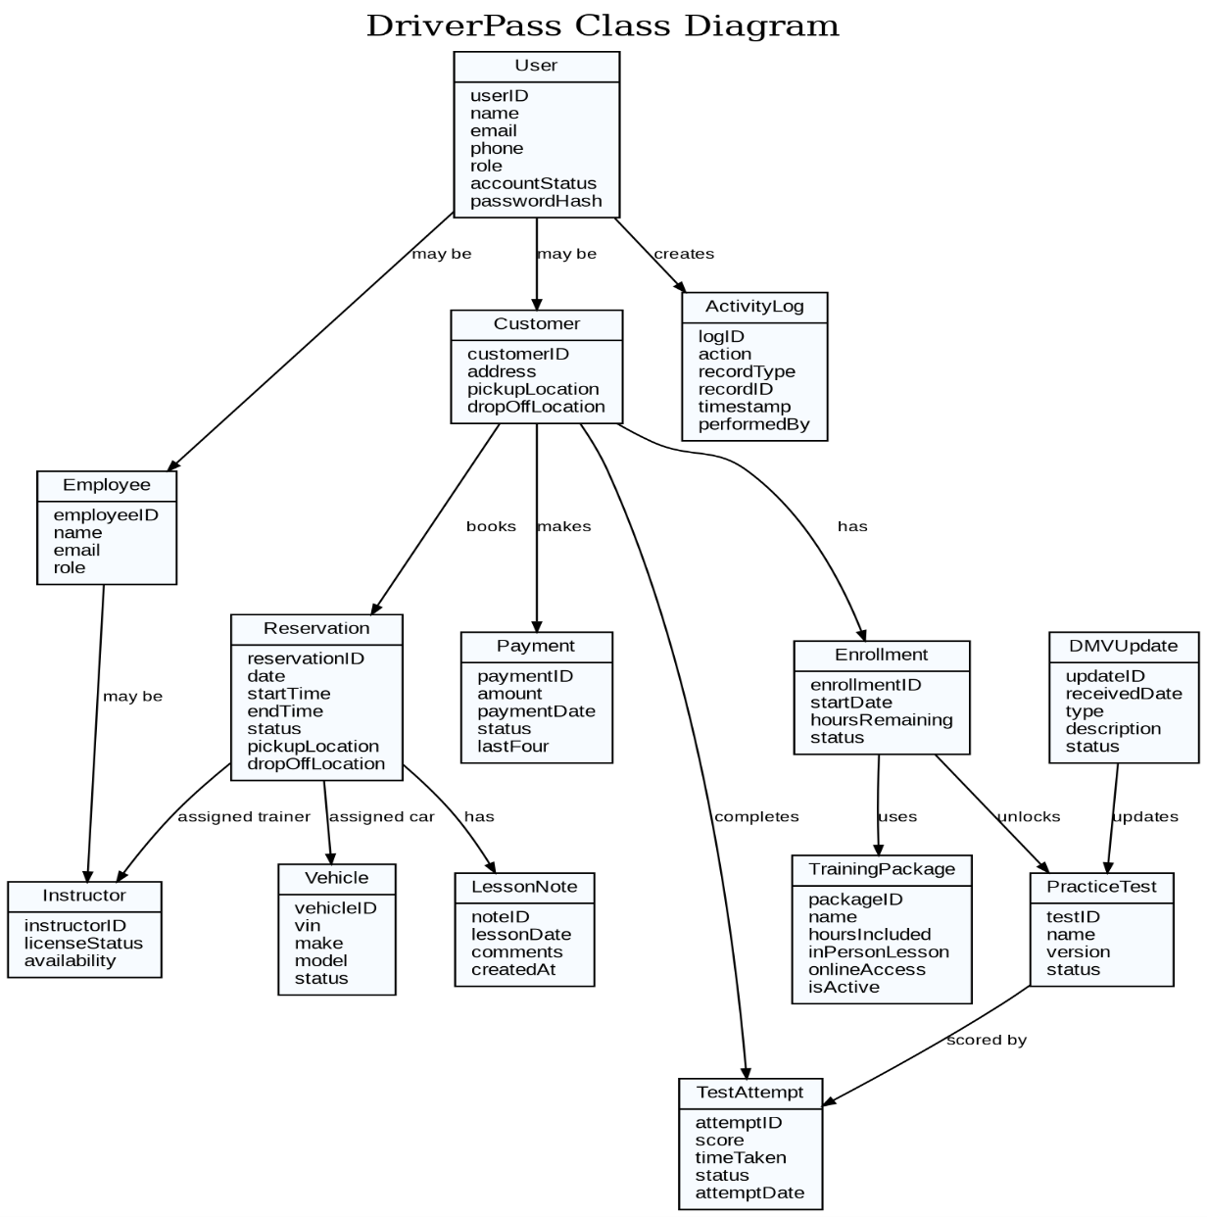

Technical Requirements
The following technical requirements support the DriverPass design and connect directly to the client’s need for online training, scheduling, reporting, security, and flexible package management.
Functional Requirements
• The system shall let customers create accounts, select a training package, and schedule, change, or cancel driving lessons online.
• The system shall let the secretary register customers and schedule appointments by phone or in person.
• The system shall track each lesson by customer, driver, vehicle, date, time, pickup location, and drop-off location.
• The system shall provide online classes, practice tests, test status, scores, and driver lesson notes when included in the package.
• The system shall allow the owner to download reports and review an activity history showing who made, changed, or canceled records.
• The system shall allow the IT officer to manage employee access and reset or block accounts.
Nonfunctional Requirements
• The system should run as a secure cloud-based website that works on computers, tablets, and mobile devices.
• The system should use role-based access so each user only sees the features needed for their job.
• The system should protect customer information and payment details through encrypted connections and secure payment processing.
• The system should be backed up regularly, monitored for problems, and designed for reliable access during business hours and online customer use.
• The system should allow DriverPass to disable packages without changing the application code.
Hardware and Hosting
• Cloud hosting for the web application, database, file storage, backups, and monitoring.
• Standard computers or mobile devices for customers and employees, with an up-to-date web browser.
• Reliable internet access for employees who need to create or change customer records.
Software and Tools
• Responsive web application for customers, secretary, instructors, owner, and IT officer.
• Relational database to store customers, packages, reservations, vehicles, instructors, payments, practice tests, notes, DMV updates, and activity history.
• Secure payment gateway so DriverPass does not directly store full credit card details.
• Email or text notification service for confirmations, password resets, and DMV update alerts.
• Reporting/export tool that can download selected information to formats such as Excel.
Infrastructure and Security
• Encrypted HTTPS connection for all pages that collect or display private information.
• Role-based permissions so users only access the information they need.
• Audit logging for important changes, including reservations, cancellations, account updates, and package changes.
• Automated backups, routine security updates, and basic monitoring to detect service problems quickly.
• API or scheduled import connection for DMV rule, policy, and sample-question updates.
System Limitations
• Offline use is limited to viewing or downloading reports; changes must be made online to avoid conflicting records.
• Adding brand-new package types or major features may require developer support.
• DMV updates depend on the availability and reliability of the DMV update source.
• Payment processing depends on a third-party payment provider.
• The first release focuses on the requested training, scheduling, reporting, and account features; future ideas can be added later.

